**Drone flyer diary – Kane Leussink**

*A young recreational drone flyer finds enjoyment and fun spending time outdoors and having a new perspective from the sky*

Kane Leussink is a 17-year-old recreational drone flyer who picked up the hobby 2 years ago while on holiday in Hawaii with his family and was instantly curious when he saw a drone fly over the ocean. He already had a passion for photography and cinematography and could see that drones could offer an interesting angle to learn from.

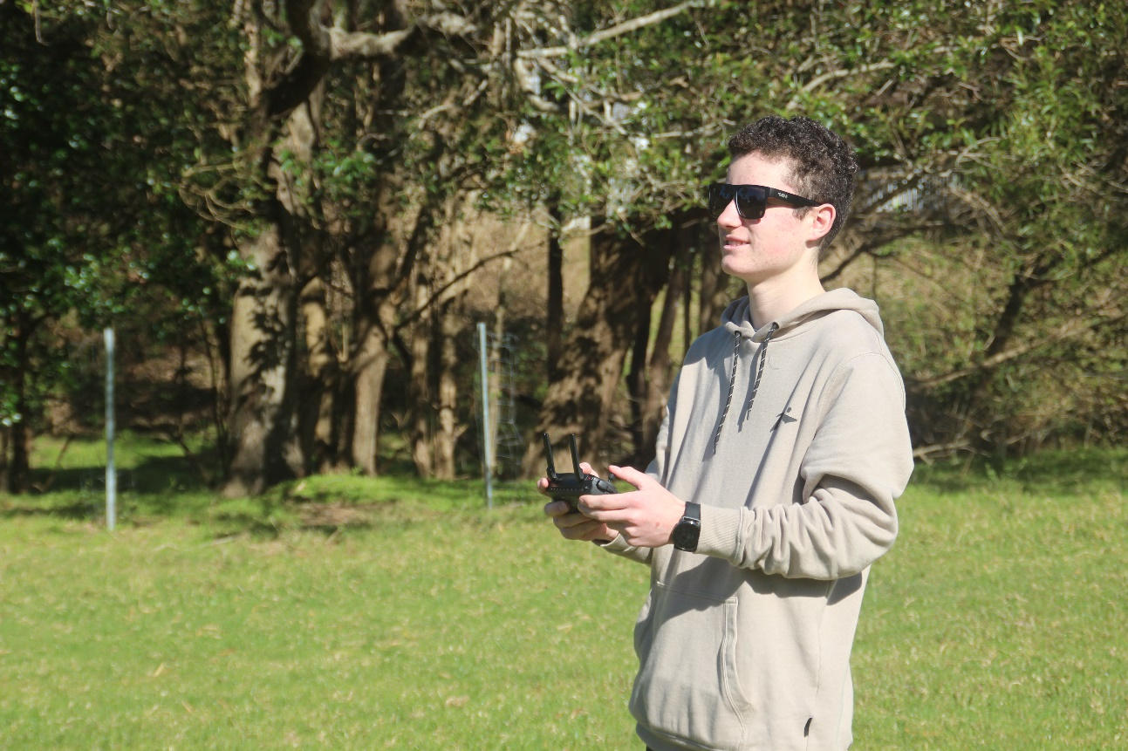

Kane Leussink flying his DJI Mavic Mini

Kane started watching YouTube videos of professional drone flyers, particularly channels with cinematography content. He instantly became inspired by what they could do with their drones and hoped that one day he could do the same.

‘After seeing the professional drone flyers on YouTube, I realised that’s what I wanted to do when I grew up, so I started saving my money and purchased my first drone 2 years ago, a DJI Mavic Mini,’ Kane said.

Often waking up early to catch the sunrise, he loves to head up to the mountains, where no people are around, to practise his flying skills.

‘I like to fly out over the ocean where you have the freedom of manoeuvrability with no people around to get some awesome shots of the east coast.’

A young entrepreneur, Kane also began taking aerial shots with his drone for the photo and video sharing website Pexels. People can download and use the images he takes. His photos quickly gained some traction and have recently reached 58,000 views.

‘It feels really cool to know people are enjoying and interested in the photos I take,’ he said.

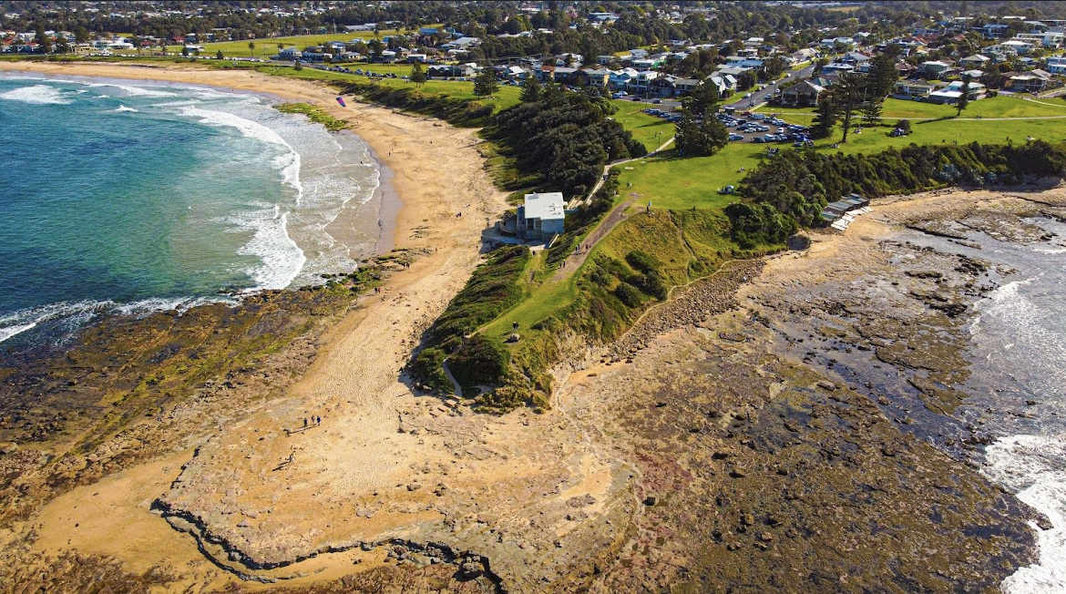

A photo that Kane took of Sandon Point Beach

Kan is interested in pursuing a career in the drone industry and would like to be a drone operator or drone photographer or cinematographer for films, TV or advertising campaigns.

‘I generally have a strong interest in drones, including how they work and what is possible with such an amazing device, and one day hope to pursue a career in this field.’

He is an avid follower of our Know Your Drone Facebook page and is a strong supporter of the drone safety rules.

He tells us the Know Your Drone website and Facebook page keeps him up to date with the rules, such as not flying drones within 100 m of marine animals in NSW or the restrictions of travelling with lithium batteries.

When asked about what he’s learnt in 2 years of flying, Kane said flying a drone can be a difficult task for beginners.

‘It’s best to go to an open park of field, and ensure no one is around, that way you can practice manoeuvring and taking photos from different angles. Sometimes the best areas to fly a drone are the most difficult, such as around mountain ranges.’

Kane believes there is a strong future for drones in all industries, specifically cinematography.

‘Drones are an incredible piece of technology that has come a long way in recent years. Manufacturers are producing higher quality cameras than ever before, developing more efficient batteries for longer flight time and are expanding the availability of drones to consumers by making them extremely affordable,’ he said.

‘I see drones as having endless opportunities with their rapidly developing technology, and I honestly believe they are the key to shaping the technology of the modern world.’

